

COURSE: | DATABASE SYSTEMS
LAB: | # 8
NAME: | MUZAMMIL BIN SOHAIL
ROLL NO.: | 22F - 3110
DEGREE: | BS - AI
SECTION: | 4A1

Question 1:
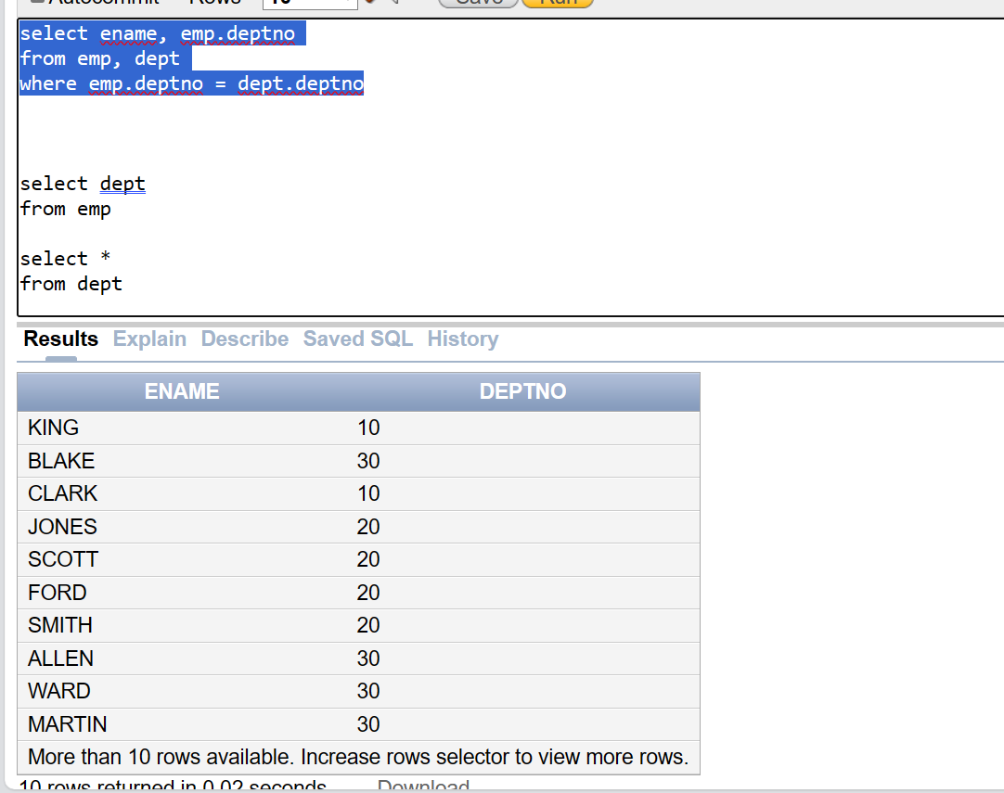
Question 2:
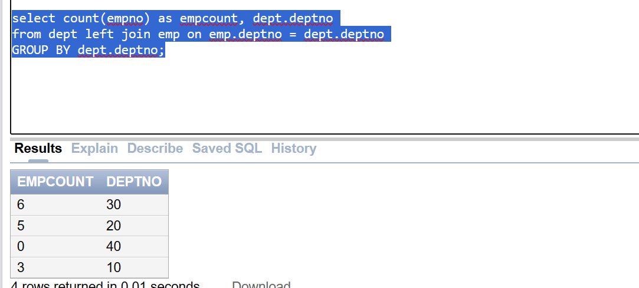
Question 3:
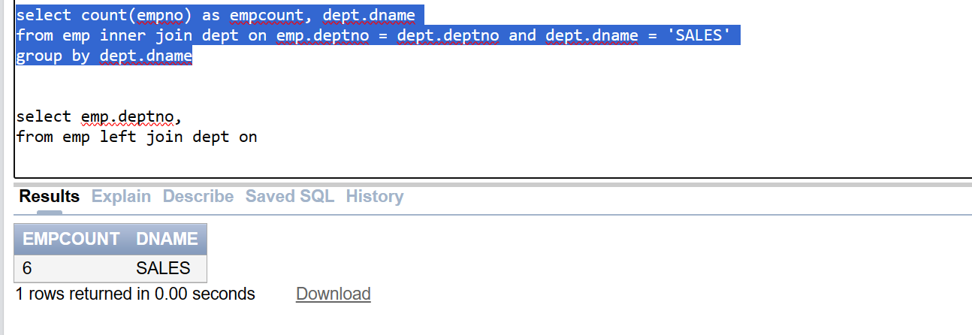
Question 4:
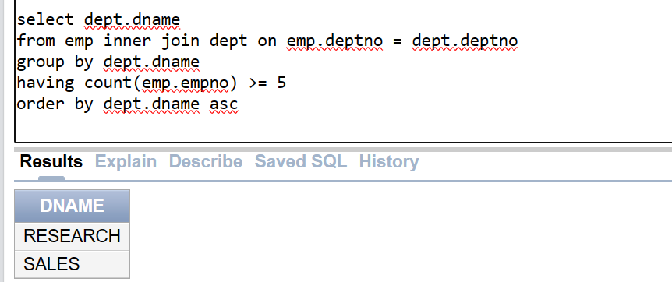
Question 5:
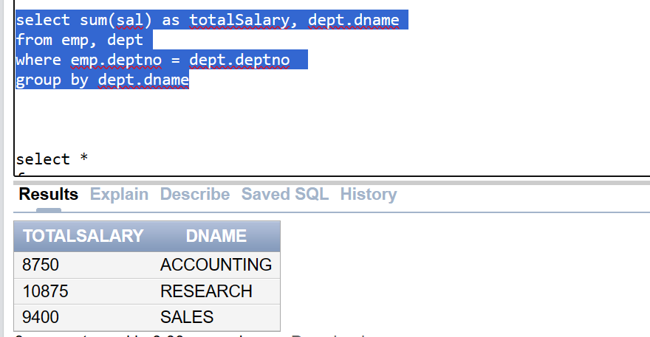
Question 6:
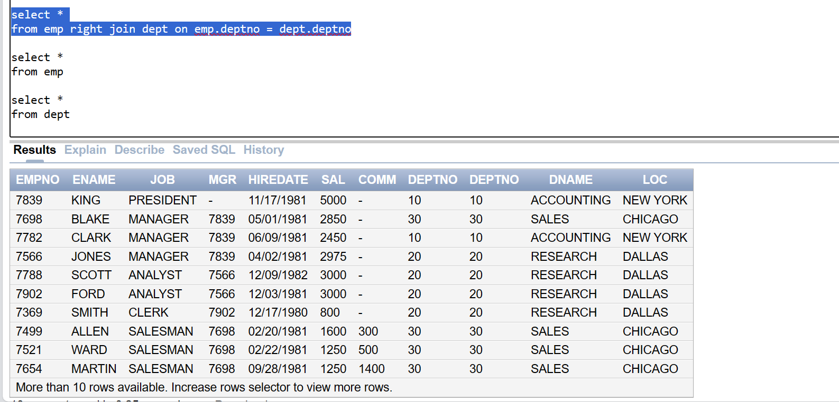
Question 7:
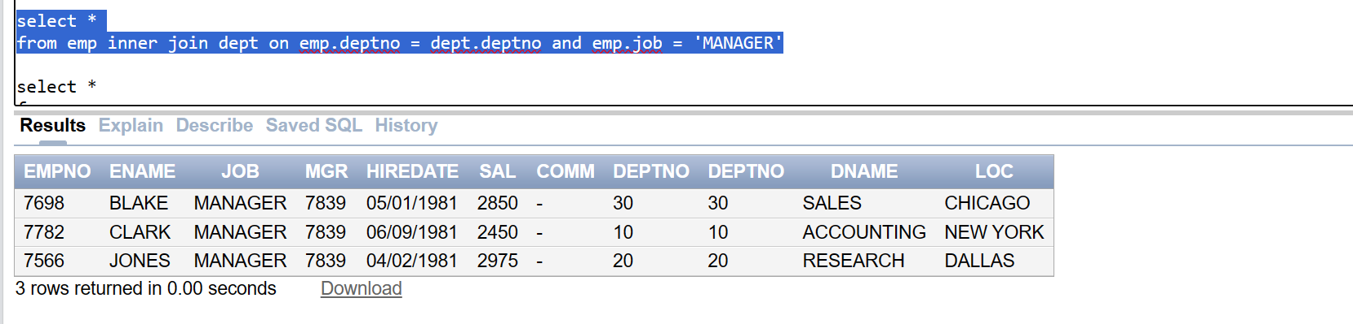
Question 8:
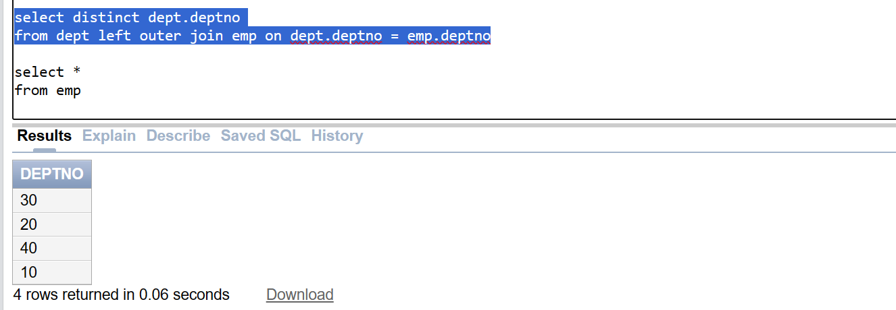
Question 9:
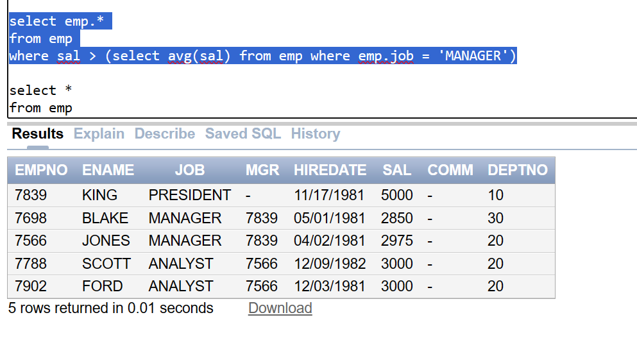
Question 10:
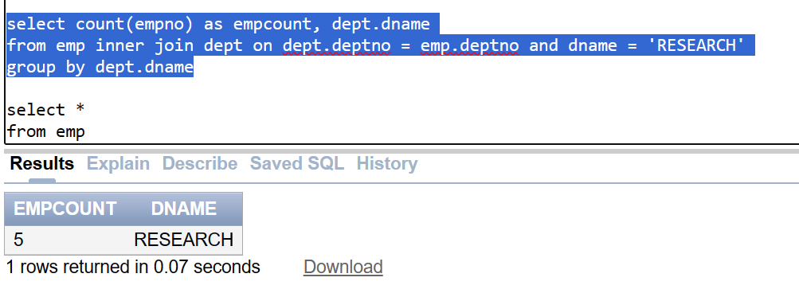

Question 11:
Question 12:
Question 13:
Question 14:
Question 15:

